Ans 1 - A cell is an important part of an excel sheet which can store data in any form of data type (date, int etc.). every cell in excel sheet will have a reference which is a combination of Column and Row. For example: if a cell has a column C and row 3 then the reference for that cell will be C3.

Ans 2 – We can protect our cells to get copied and in order to that following steps need to be followed;

you need to go into Menu bar >Review > Protect sheet > Select the check boxes which you want in the Allow All Users of This Worksheet To list box that you still want to be functional when the worksheet protection is operational. > Password then Excel opens the Confirm Password dialog box to enter Re-enter the password.

By entering password, you can secure your worksheet from getting copied by others.

Ans 3 - In order to move 1 worksheet into another workbook we can do the following steps:

1 Drag your mouse to the sheet name where you want to copy

2 left click on the sheet name and hold it

3 Then drag your mouse to another workbook and release it wherever you want to move in the new workbook.

In order to copy 1 worksheet into another workbook we can do the following steps:

1 Drag your mouse to the sheet name where you want to copy

2 left click on the sheet name and hold it

3 Then drag your mouse to another workbook and before releasing it press the “ctrl” key then release it wherever you want to move in the new workbook.

Note- both moving and copying involves similar procedure just a small difference of ctrl key.

Ans 4 – Ctrl + N is the shortcut key used as a shortcut for opening a new window document.

Ans 5 -

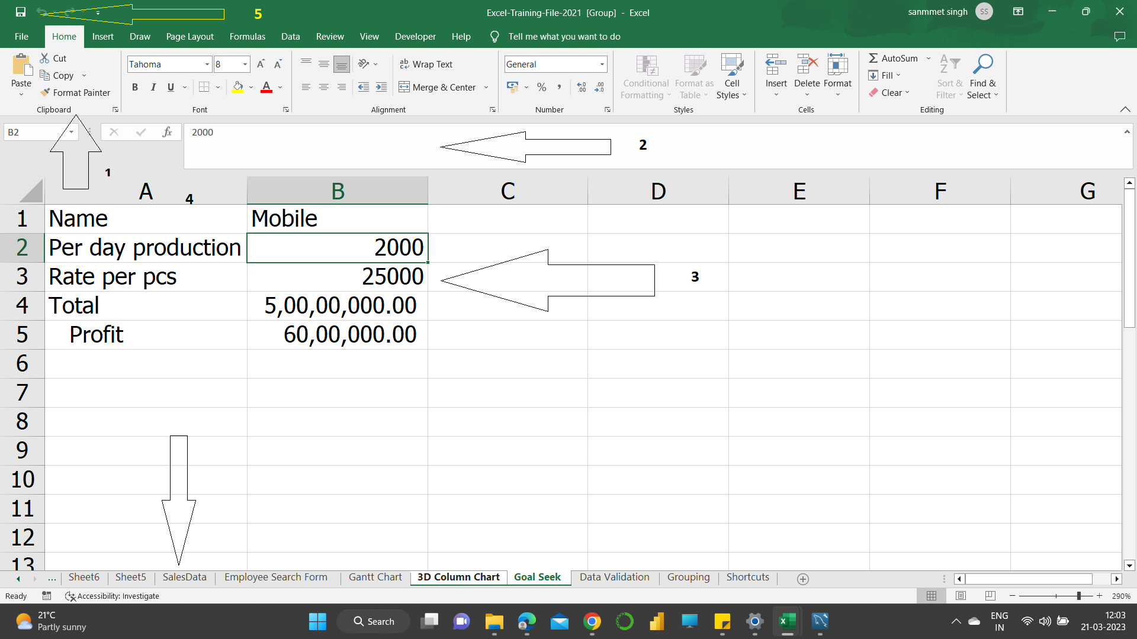

On the above image we can have a look at the interface of an Excel worksheet below are the points which we can have a look at:

1. **Ribbon**– a collection of Excel capabilities organized into **groups** corresponding to some ribbon tab. For example, the **Home, Data, View etc** ribbon displayed.
2. **Formula Bar –** where we can write, edit and view the formulae which we have written in a cell
3. **Cell** - A cell is an important part of an excel sheet which can store data in any form of data type (date, int etc.). every cell in excel sheet will have a reference which is a combination of Column and Row. For example: if a cell has a column C and row 3 then the reference for that cell will be C3.
4. **Sheet Name** – It is the name of the sheet, we can have different names for different sheets.
5. **Save Icon** – By clicking on the save icon we can save the work which we have done in the workbook.

Ans 6 - Relative reference is a type of cell reference in Excel. This reference changes when the formula is copied to any other cell or any other worksheet. Relative cell references are used whenever calculations need to be repeated. For example -

in cell D1, we have “=E1+F1.” On copying this formula to cell E2, the formula becomes “=F2+G2.” This is because the first formula refers to two cells on the right of cell D1 while the second formula refers to two cells on the right of cell E2. Cells E1 and F1 are to the right of cell D1 and cells F2 and G2 are to the right of cell E2.